**PROJECT 2:**

**Deploying a web server in Ubuntu Instance.**

**Task 1:Create a windows instance using AMI :Ubuntu Server 18.04 LTS (HVM)**

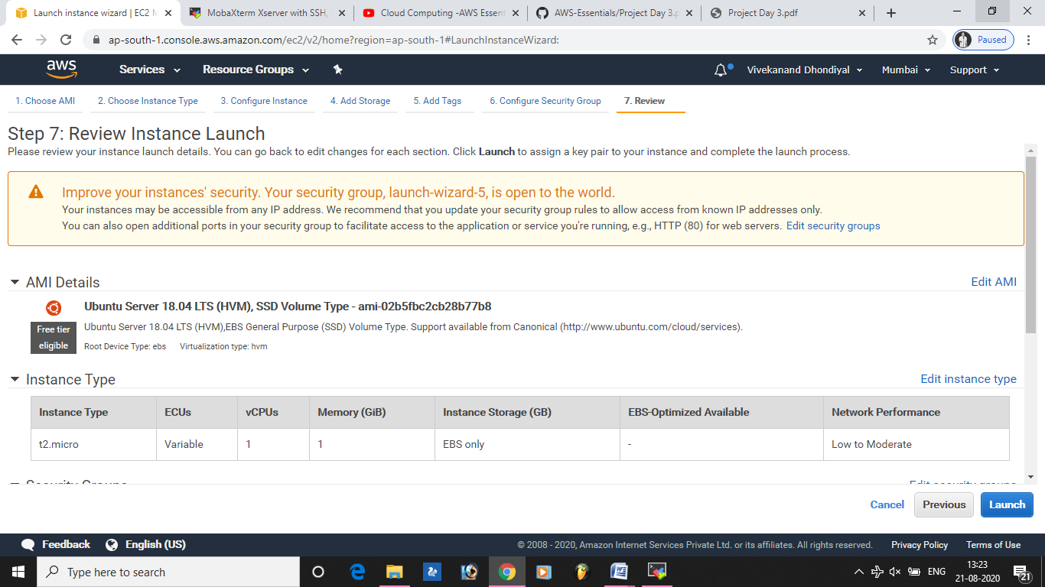

**Task 2:Download and install MobaXterm Portable Edition.**

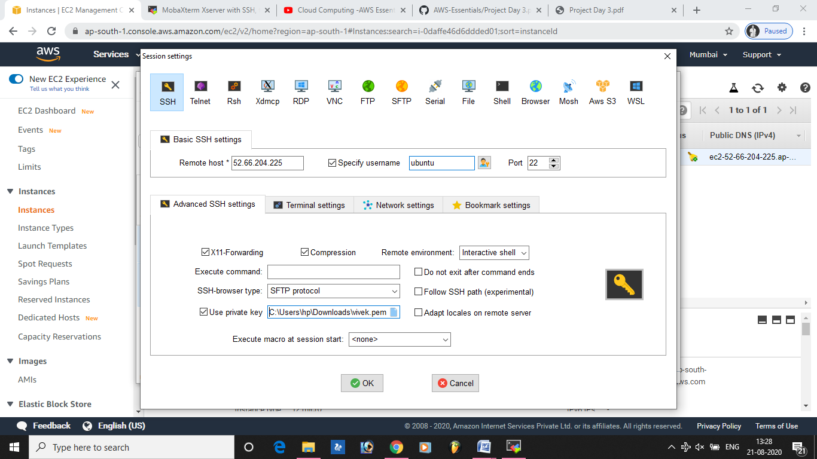

**Task 2:Launch the Ubuntu instance using SSH**

**Note:Username is ubuntu**

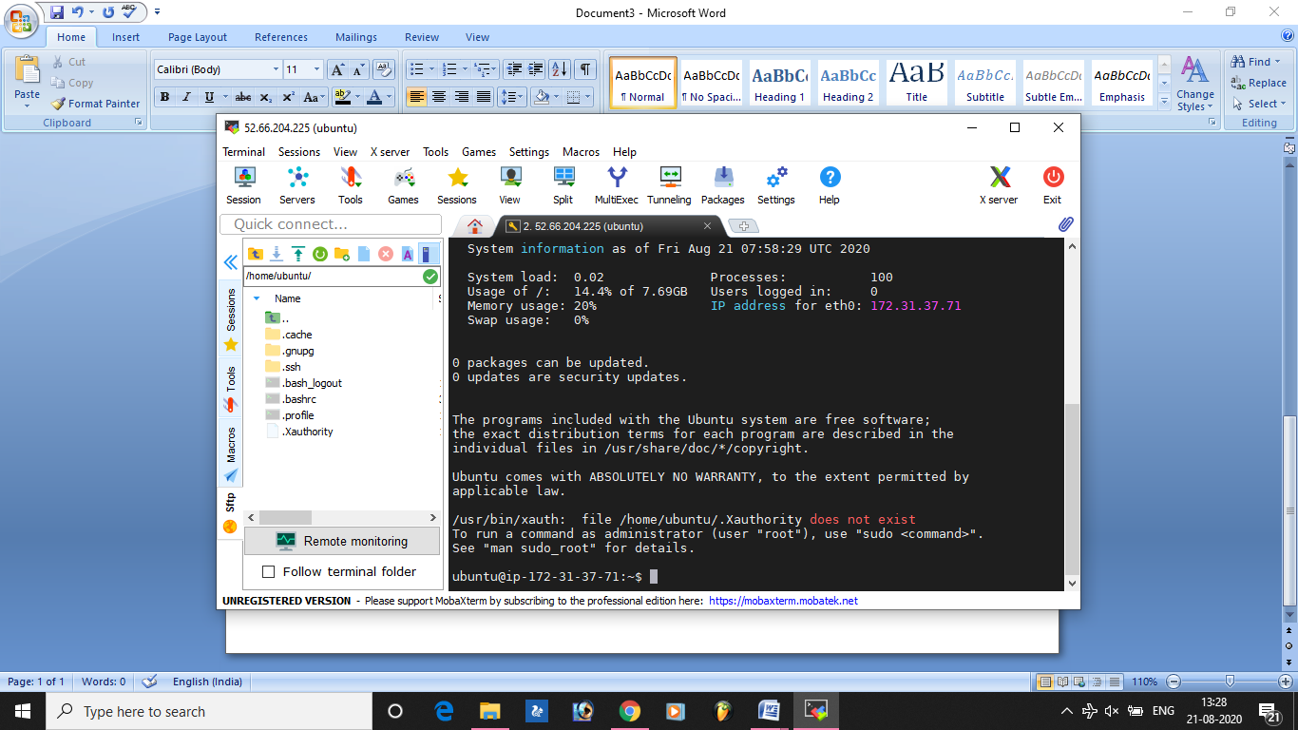

**Task 3:Install ngnix web server using bash**

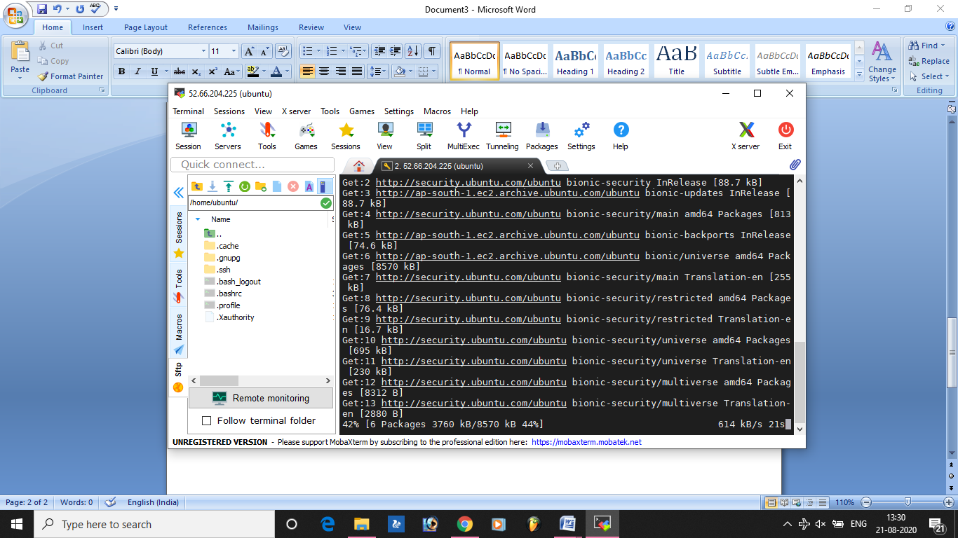

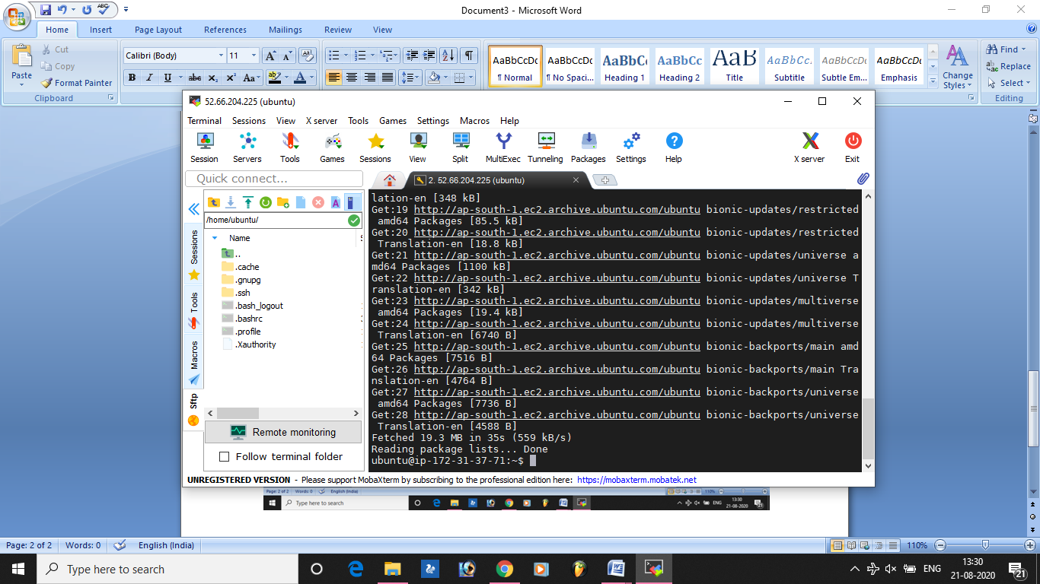

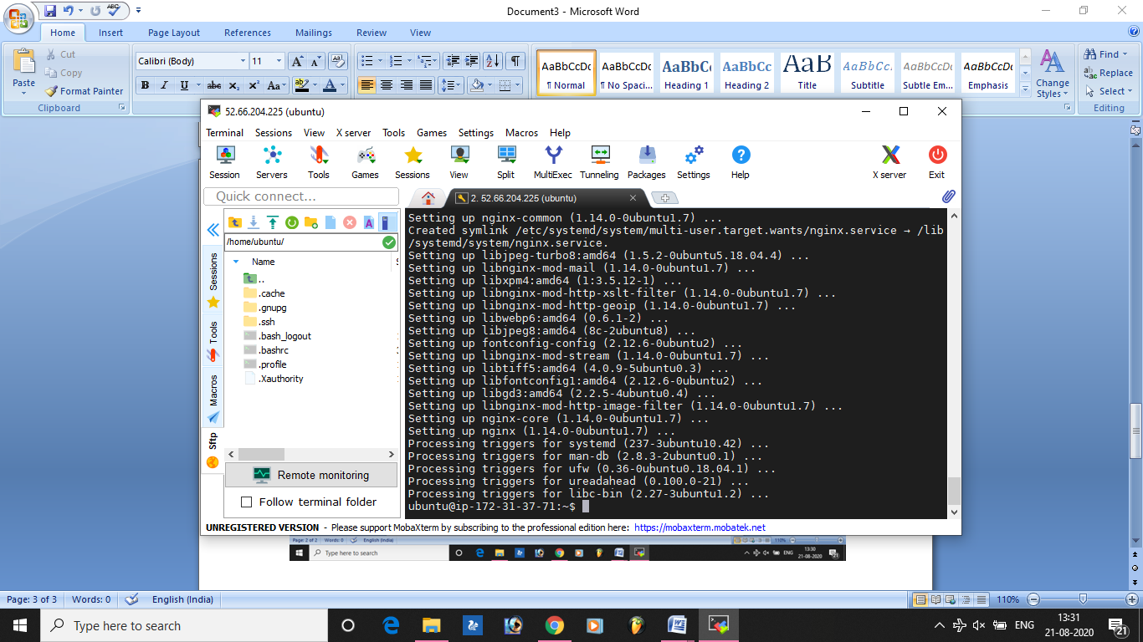

**Task 4:Verify successful installation of ngnix.**

